MARKET ELASTICITY

This topic for experienced GMC-players only, because information requires serious skills and background.

We have already understood [how to test factors](https://gmcworld.org/blog/how-to-test-factors), now lets look at basic principles of market mechanic in the GMC simulator. Experienced players know that impact of demand factors to increase sales of their products is very different between groups with weak and strong competitors. In first rounds of the championship experienced teams have not got worthy opponents in the group and sales go up the hill. But in semifinal weak teams eliminated and teams begin a persistent struggle for the leadership. In this case, if we make the same decisions as in first rounds, sales will grow less. That is because elasticity of the demand factors decreased, competition in the group became stronger. Why it happens and how to forecast sales in future periods?

Previously, we estimated elasticities for direct and corporate advertising in 1 period for each scenario. But elasticity of demand factors is not constant and depends on the strength of competitors in the group. It means elasticity for elasticity of factors. Lets check price elasticity in 1 period on scenario 12C1 and 12C3.

**Scenario 12C1**

In this table you can see price elasticities for scenario 12C1 - relative % change in sales when price changes by 1%. For example, prices increasing for product 1 in Internet by 1% will decrease sales by -2.175%. Data was found from multiple perfect tests and can be used unconditionally.

|  |  |  |  |
| --- | --- | --- | --- |
| Elasticity | Product 1 | Product 2 | Product 3 |
| EU | -3,186 | -1,927 | -2,449 |
| Nafta | -5,010 | -2,739 | -3,510 |
| Internet | -2,175 | -1,418 | -1,794 |

In this table sum of market shares of all companies according to marketing information in 1 period. Amount of shares for product 1 in Internet equal to 76.2, which means that the market is occupied 76.2% by your company and competitors in the group. Market load may vary depending on level of competitors in the group. In tests elasticity of product 1 in Internet ranged from 70% to 80%.

|  |  |  |  |
| --- | --- | --- | --- |
| Market load | Product 1 | Product 2 | Product 3 |
| EU | 52,8 | 70,6 | 63,8 |
| Nafta | 40,5 | 69,1 | 58,9 |
| Internet | 76,2 | 84,6 | 81,8 |

Lets put prices elasticity and market load on graph. In the graph vertically - market load (EU - blue, Nafta - green, Internet - red). Horizontal - price elasticity in 1 period.

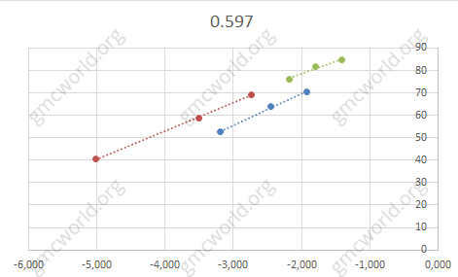

The higher market load, the lower price elasticity. This means that the same price change (for example, decreasing by 5 units) in weak group with lower market load you will get more sales growth than in the group with high market load.

**Scenario 12C3**

Lets do the same with price elasticity from scenario 12C3.

|  |  |  |  |
| --- | --- | --- | --- |
| Elasticity | Product 1 | Product 2 | Product 3 |
| EU | -6,372 | -6,527 | -3,400 |
| Nafta | -6,372 | -6,527 | -3,400 |
| Internet | -3,774 | -3,172 | -1,924 |

Sum of market shares of all companies according to marketing information in 1 period.

|  |  |  |  |
| --- | --- | --- | --- |
| Market load | Product 1 | Product 2 | Product 3 |
| EU | 20,6 | 20,1 | 49,9 |
| Nafta | 30,4 | 29,6 | 62,6 |
| Internet | 60,5 | 68,4 | 81,8 |

In the graph vertically - market load (EU - blue, Nafta - green, Internet - red). Horizontal - price elasticity in 1 period.

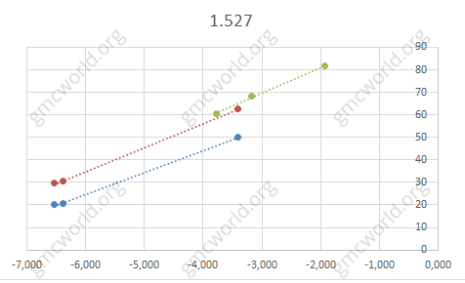

Analysis shows line points slight deviations from trend, market load also slightly differs between each other - the difference is about 5%, which is caused by average values of market shares in several test groups. We can conclude that probably market load in current period affects on demand factors in current period.

Compatible elasticity for each market from scenarios 12C1 and 12C3 on the same graph.

**EU**

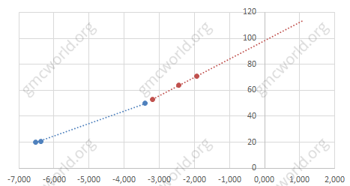

**Nafta**

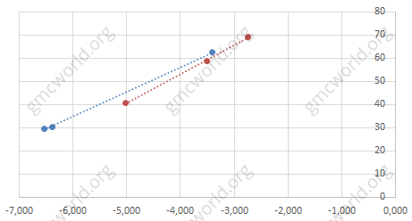

**Internet**

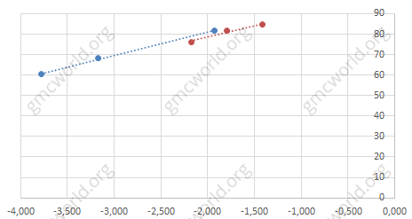

Taking into account estimate error of price elasticity and market load, there is no difference between scenarios. Elasticity is reduced in direct proportion to the market load. When you forecast sales, it is necessary to forecast market load changes to correct influence of demand factors.

We extend trend line to the intersection with axis OY. Continue trend line from scenario 12C1 (red) as the most clearly calculated.

**EU**

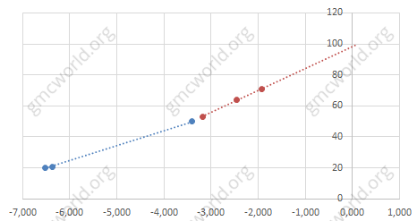

**Nafta**

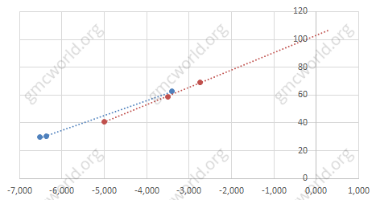

**Internet**

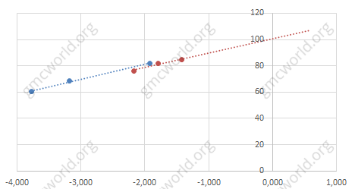

Trend line crosses axis OY at 100. That means when trend reaches 100% market load, elasticity drops to 0. So to go beyond 100% is impossible, it is a natural mechanism that limits market expansion in GMC simulator.

Calculate elasticity of price elasticity for each market. For EU and Nafta I removed 2 points where was large error in estimation of market load. Add control point on axis OY - 0 elasticity, market load 100.

**EU**

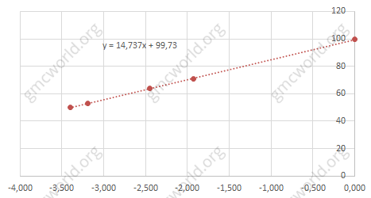

**Nafta**

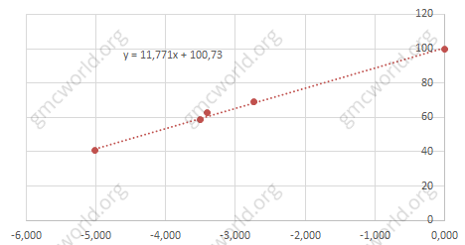

**Internet**

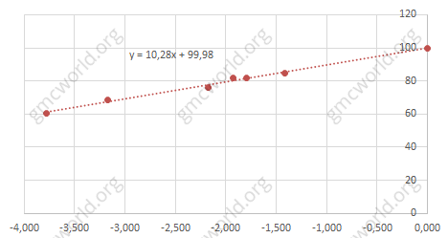

Elasticity of price elasticity for Nafta and Internet market is about the same 11.77 and 10.28. While elasticity for EU market is much higher 14.73.

**Hints**

1．Elasticity of demand factors is directly proportional to the market load.

市场弹性

这个话题仅供经验丰富的GMC玩家参考，因为信息需要认真的技能和背景。

我们已经了解了如何测试因素，现在看看GMC模拟器市场机制的基本原理。有经验的玩家知道，需求因素对产品销售增加的影响在弱势和强势竞争对手的群体之间是非常不同的。在第一轮的冠军赛中，经验丰富的队伍在球队中没有得到有价值的对手，而销售额则上升了。但在半决赛弱势队伍中，球队开始了持续的领导斗争。 在这种情况下，如果我们做出与第一轮相同的决定，销售额将会减少。那是因为需求因素弹性下降，集团竞争愈演愈烈。 为什么会发生这种情况，以及如何预测未来的销售额？

以前，我们估计每个场景的1个时期的直接和公司广告的弹性。但是需求因素的弹性并不是一直依赖于竞争对手的实力。它是指因素弹性的弹性。让情景12C1和12C3检查1个时期的价格弹性。

**情景12C1**

在这个表中，您可以看到情景12C1的价格弹性 - 当价格变化1％时销售额的相对变化百分比。 例如，互联网产品1的价格上涨1％，销售额下降了-2.175％。 数据来自多次完美测试，无条件使用。

|  |  |  |  |
| --- | --- | --- | --- |
| 弹性 | 产品1 | 产品2 | 产品3 |
| 国内 | -3.186 | -1.927 | -2.449 |
| 北美 | -5.010 | -2.739 | -3.510 |
| 互联网 | -2.175 | -1.418 | -1.794 |

 在此表中，所有公司的市场份额按照1个时段的市场信息计算。 互联网产品1的份额等于76.2，这意味着贵公司和集团竞争对手的市场占有率为76.2％。 市场负担可能因组内竞争对手的水平而异。 在测试中，产品1在互联网上的弹性范围从70％到80％不等。

|  |  |  |  |
| --- | --- | --- | --- |
| 市场负荷 | 产品1 | 产品2 | 产品3 |
| 国内 | 52.8 | 70.6 | 63.8 |
| 北美 | 40.5 | 69.1 | 58.9 |
| 互联网 | 76.2 | 84.6 | 81.8 |

 价格弹性和市场负担在图上。 在图中垂直 - 市场负荷（国内 - 蓝色，北美 - 绿色，互联网 - 红色）。 水平 - 1个时期的价格弹性。



市场负荷较高，价格弹性较低。 这意味着市场负荷较小的弱势群体的价格变化（例如减少5个单位），您的销售额增长将高于市场负荷较大的集团。

**场景12C3**

让情况12C3的价格弹性也一样。

|  |  |  |  |
| --- | --- | --- | --- |
| 弹性 | 产品1 | 产品2 | 产品3 |
| 国内 | -6,372 | -6,527 | -3,400 |
| 北美 | -6,372 | -6,527 | -3,400 |
| 互联网 | -3,774 | -3,172 | -1,924 |

所有公司的市场份额按照1个时段的营销信息总和。

|  |  |  |  |
| --- | --- | --- | --- |
| 市场负荷 | 产品1 | 产品2 | 产品3 |
| 国内 | 20.6 | 20.1 | 49.9 |
| 北美 | 30.4 | 29.6 | 62.6 |
| 互联网 | 60.5 | 68.4 | 81.8 |

 在图中垂直 - 市场负荷（国内 - 蓝色，北美 - 绿色，互联网 - 红色）。 水平 - 1个时期的价格弹性。



分析显示线路点略有偏离趋势，市场负荷也略有不同 - 差距约为5％，这是由几个测试组的市场份额平均值引起的。 我们可以得出结论，本期可能的市场负荷会影响当期的需求因素。

在相同图形上的情景12C1和12C3的每个市场的兼容弹性。

**国内**



**北美**



**互联网**



考虑到价格弹性和市场负荷的估计误差，情景没有差异。 弹性与市场负荷成正比。 当您预测销售量时，有必要预测市场负荷变化以纠正需求因素的影响。

我们将趋势线延伸到与轴OY的交点。从情景12C1（红色）继续趋势线，最清晰的计算。

**国内**



**北美**



**互联网**



 趋势线跨越轴OY为100.这意味着当趋势达到100％的市场负荷时，弹性下降到0.所以超过100％是不可能的，它是限制GMC模拟器市场扩张的自然机制。

计算每个市场的价格弹性弹性。 对于欧盟和Nafta，我删除了2个点，在市场负担估计上出现了很大的误差。 在轴上添加控制点OY - 0弹性，市场负荷100。

**国内**



**北美**



**互联网**



北美和互联网市场的价格弹性大致相同为11.77和10.28。而国内市场的弹性是更高的14.73。

**提示**

1．需求因素的弹性与市场负荷成正比。